H.T No
Regulations:
A17

Sreenidhi Institute of Science and Technology
(An Autonomous Institution)
Code No: 6EC13 Date: 20-Mar-2021(AN)

B.Tech III-Year II- Semester External Examination, March/April - 2021 (Supplementary)
MACHINE LEARNING (CSE, IT and ECM)

Time: 3 Hours Max.Marks:75

Note: a) No additional answer sheets will be provided.
b) All sub-parts of a question must be answered at one place only, otherwise it will not be valued.
c) Missing data can be assumed suitably.

ANSWER ANY 5 OUT OF 8 QUESTIONS. EACH QUESTION CARRIES 15 MARKS.

Bloom's Cognitive Levels of Learning (BCLL)

Remember | L1 | Apply | L3 | Evaluate | L5
Understand | L2 | Analyze | L4 | Create | L6

 |  |  | BCLL | CO(s) | Marks
1. | a) | The decision boundary hyperplane found by the Perceptron has equation y(x) = wT x + b = 0. For a point x’, minimize ||x – x’||2 to show that the shortest distance from the point to the hyperplane is |y(x’)|/||w||. | L2 | CO1 | [8M]
 | b) | With the help of neat diagram, explain the McCulloch and Pitts Neurons Model and its limitations. | L2 | CO1 | [7M]
2. | a) | A hospital manager wants to predict how many beds will be needed in the geriatric ward. He asks you to design a neural network method for making this prediction. He has data for the last 5 years that cover:  - The number of people in the geriatric ward each week.  - The weather (average day and night temperatures).  - The season of the year (spring, summer, autumn, winter).  - Whether or not there was an epidemic on (use a binary variable: yes or no).  Design a suitable Multi-Layer Perceptron for this problem, considering how you would choose the number of hidden neurons, the inputs (and whether there are any other inputs you need) and the preprocessing, and whether or not you would expect the system to work. | L3 | CO2 | [8M]
 | b) | The alternative activation function that can be used in tanh(h). Show that tanh(h) = 2g(2h) − 1, where g is given by Equation given below  a = g(h) = 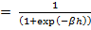  Use this to show that there is an exactly equivalent Multi-Layer Perceptron using the tanh activation function. | L3 | CO2 | [7M]
3. | a) | Consider the table given below and construct a decision tree to classify which attributes make a person attractive and determine the rules. | L3 | CO3 | [8M]
  Height | Hair | Eyes | Attractive?
  Small | Blonde | Brown | No
  Tall | Dark | Brown | No
  Tall | Blonde | Blue | Yes
  Tall | Dark | Blue | No
  Small | Dark | Blue | No
  Tall | Red | Blue | Yes
  Tall | Blonde | Brown | No
  Small | Blonde | Blue | Yes
 | b) | Consider the table given below and construct a decision tree and determine the values of Entropy and Gain. | L3 | CO3 | [7M]
  Deadline? | Is there a Party? | Lazy? | Activity
  Urgent | Yes | Yes | Party
  Urgent | No | Yes | Study
  Near | Yes | Yes | Party
  None | Yes | No | Party
  None | No | Yes | Pub
  None | Yes | No | Party
  Near | No | No | Study
  Near | No | Yes | TV
  Near | Yes | Yes | Party
  Urgent | No | No | Study
4. | a) | Explain Locally Linear Embedding Algorithm with an example. | L2 | CO4 | [8M]
 | b) | Explain Multi-Dimensional Scaling Algorithm with an example. | L2 | CO4 | [7M]
5. | a) | Suppose that there is a coin and there is person demonstrating that the coin is fair, but then makes it turn up heads many times in a row. You notice that he actually has two coins, and swaps between them with sleight-of-hand.  Watching, you start to see that he sticks to the fair coin with probability 0.4, and to the biased coin with probability 0.1, and that the biased coin seems to come up heads about 85% of the time. Construct a hidden Markov model for this problem, construct an observation sequence, and use the Viterbi algorithm to estimate the states. | L3 | CO5 | [8M]
 | b) | Compute the probability of taking notes (N) in the Bayesian network shown in Figure below. The problem describes the chance of you taking notes in the lecture or sleeping (S) according to whether or not the course was boring (B) based on whether or not the professor is boring (L) and the content is dull (C). Compute the chance of falling asleep in a lecture given that both the professor and the course are boring.  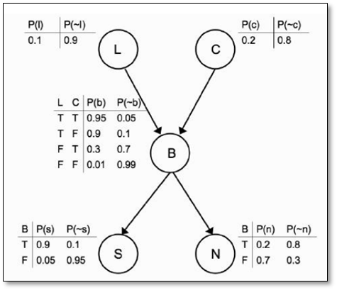 | L3 | CO5 | [7M]
6. | a) | Illustrate with an example Inductive Bias in Explanation Based Learning | L3 | CO6 | [8M]
 | b) | Explain KBANN Algorithm with an Example | L2 | CO6 | [7M]
7. | a) | Explain Inductive Learning Hypothesis | L2 | CO1 | [5M]
 | b) | Explain different output activation functions in Multi-Layer Perceptron. | L2 | CO2 | [5M]
 | c) | Explain ID3 algorithm | L2 | CO3 | [5M]
8. | a) | Explain factor Analysis | L2 | CO4 | [5M]
 | b) | Explain HMM Viterbi Algorithm | L2 | CO5 | [5M]
 | c) | Describe Knowledge Level Learning | L2 | CO6 | [5M]
-- 00 -- 00 –

